From Napa Valley to the Barossa Valley: New World Winery Map Measures the Terroir of Every Vineyard on the Planet
Umag, Croatia — Oct. 1, 2026 — World Winery Map, launched in September as the most comprehensive interactive map of world viticulture, now brings together 4,308,241 vineyard parcels and 104,551 wineries across 90 countries. Immediately after its launch, the map attracted strong interest from wineries around the world.
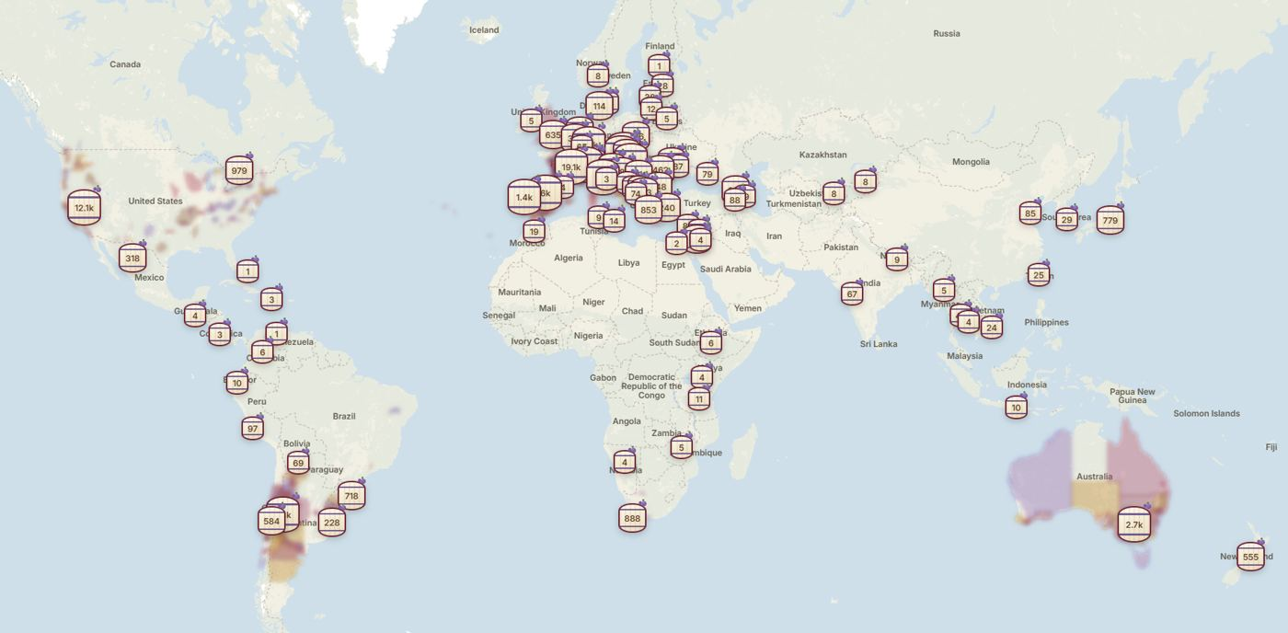
World Winery Map: more than 100,000 wineries in 90 countries. Photo: World Winery Map.
Tracking climate change vineyard by vineyard is becoming essential for the wine world: rising temperatures are already shifting harvest dates and grape ripening, and are redrawing the boundaries of where each grape variety is grown and what kind of wine it makes.
For every single vineyard on the map, users can access highly specific geospatial data, including elevation, solar radiation and slope, alongside critical viticultural metrics like soil composition, the Huglin index and average temperatures during the vine growing season.
"For each parcel, we extracted the exact coordinates and calculated the elevation, slope, and aspect using the Copernicus GLO-30 terrain model, then layered climate data on top of that," said Matija Gavrilović, founder of World Winery Map. "For larger parcels, we measure up to 16 control points, which is why elevation is presented as a precise range rather than a single number. We also calculated the slope, solar radiation, rainfall, wind, soil type, and geology wherever data was available."
The vineyard parcels are aggregated from 38 independent sources. Twenty-two of these are official government registers. Data coverage is densest in the European Union, where such registers are public domain. In other regions, vineyard data is sourced from national agricultural censuses, satellite land cover analytics, and other unofficial sources.
The map outlines 98,719 specific wine region boundaries, scaling from massive macro-regions down to individual named plots. This includes 2,815 official wine regions, subregions, and appellations, alongside 95,904 named vineyard sites. Among these are 89,634 French lieux-dits pulled from the state cadastre, 4,513 Austrian Rieden, 1,655 German Lagen, and 102 Luxembourgish sites. The system distinguishes internal regional tiers, mapping 691 premier cru and 79 grand cru sites in France, as well as 192 AVAs in the United States.
Wine areas are recorded using the exact boundaries and legal nomenclature designated by their respective nations. This includes INAO delimitations in France, AVA borders in the U.S., Wine Australia's Geographical Indications, ministerial decrees in Spain, Chile, and Romania, state geoportals for Austrian Rieden and German Weinlagen, as well as national regulations in Croatia, Hungary, and Slovenia. Users can select any region to read essential facts, review borders, check average rainfall and elevation, and analyze viticultural data like the Winkler index. World Winery Map is already in touch with official bodies in several countries, with the aim of keeping the map as accurate as possible.
The platform is tailored for both industry professionals and wine travelers. An integrated geolocation system allows users to instantly locate nearby wineries and receive navigation instructions to the estate, wherever they are in the world. For wine enthusiasts who prefer to explore from home, the platform offers a detailed virtual journey through global wine geography.
"Building a system of this magnitude required processing more than four million geospatial polygons and precisely intersecting them with topographical and climate layers," the founder noted. "The result is the most comprehensive digital archive of world viticulture ever created."
Winemakers worldwide are invited to claim their winery profiles on the platform for free. By taking ownership of their pages, producers can update tasting room hours, verify visitor policies, claim their specific vineyard parcels, and update data on planted grape varieties, actively participating in maintaining the world's most accurate and detailed wine map.
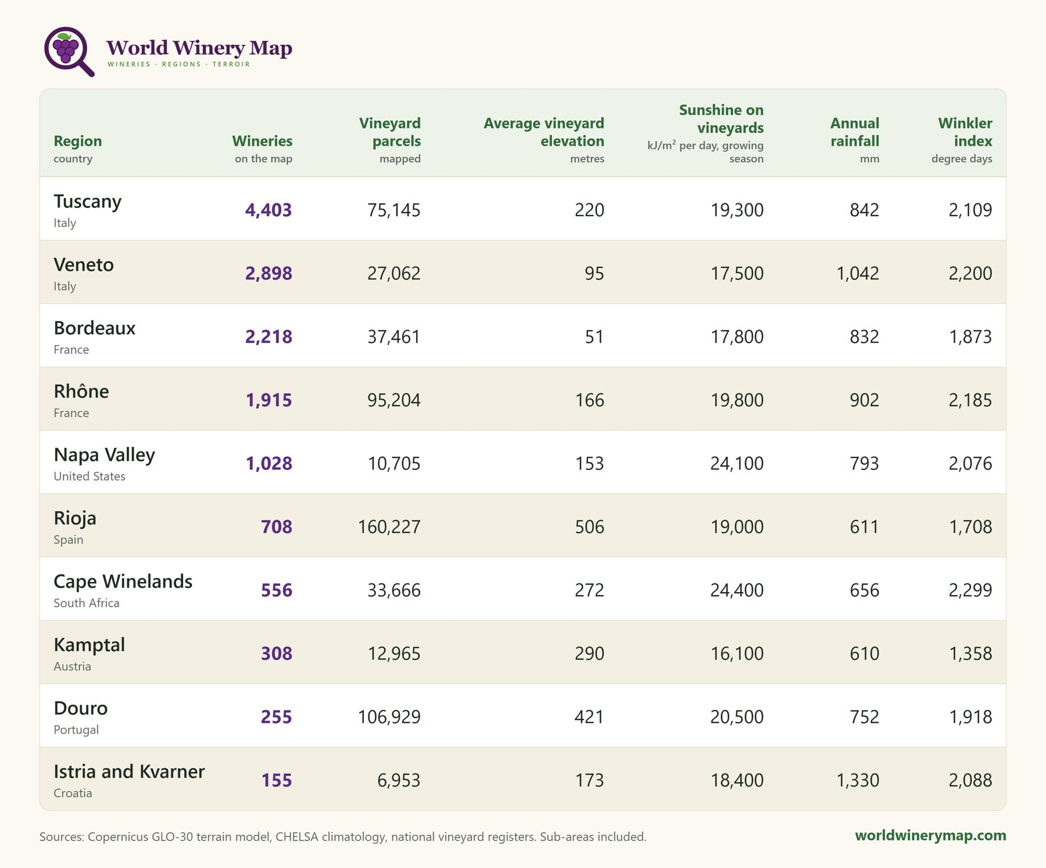
Detailed terroir metrics and climate indices provided for mapped wine regions on World Winery Map. Photo: World Winery Map.
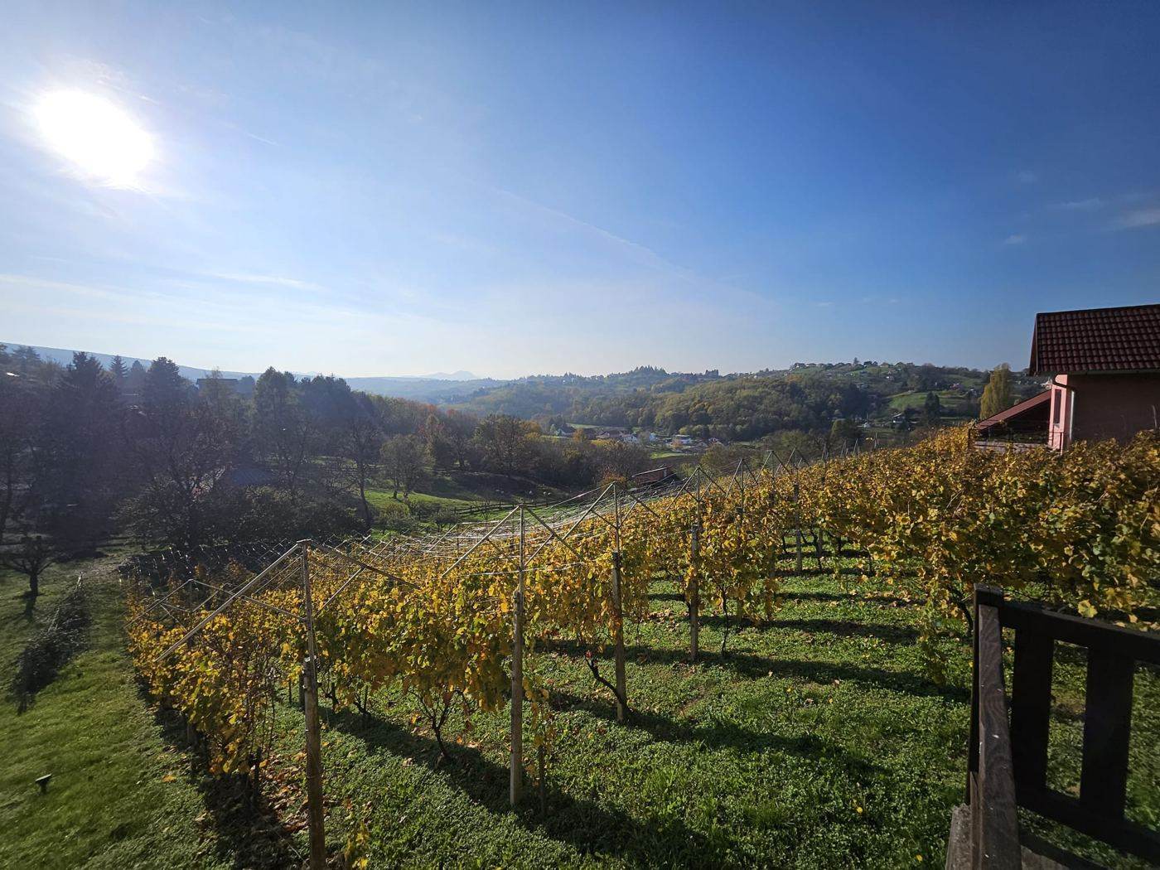
Vineyards in Croatia. The interactive map charts more than 4.3 million vineyards across 90 countries. Photo: World Winery Map.
All materials on this page may be used freely, in full or in part. Credit: World Winery Map.

